18 Jan 2007

APC and EB1 Interactions at Microtubule Ends: Their Importance in Mitosis.

Dr. Anke Brüning-Richardson

Cancer is a class of diseases characterized by uncontrolled cell division and the ability of these cells to invade other tissues, either by direct growth into adjacent tissue (invasion) or by migration of cells to distant sites (metastasis). Aneuploidy, or abnormal chromosome content, is the most common characteristic of solid tumours. Aneuploidy may arise due to errors in mitosis. Microtubules form the spindle, an essential structure of mitosis. Many proteins are associated with microtubules including the adenomatous poliposis coli protein, APC, and its binding partner, the end binding protein EB1.
In this talk, I will discuss recent findings of the functions of EB1 and APC in mitosis by live imaging of microinjected NRKE cells and the implication for their role in the development of colorectal cancer.

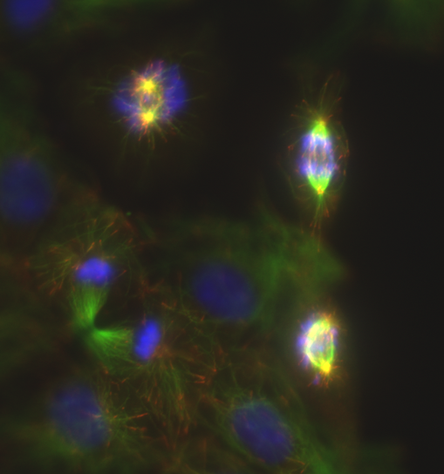

NRKE cells at various stages of mitosis (Immunostaining: blue-DAPI, green – anti-tubulin, red - anti-EB1)

